**Great and Little Barugh Parish Council Newsletter**

**June 2022**

Welcome to our Parish newsletter, the purpose of which is to keep all residents of Great and Little Barugh up to date with news of Parish Council business and plans for the future.

On Friday 3rd June we held our Picnic on the Green, to celebrate the Queen’s Platinum Jubilee. It was a lovely afternoon, with many visitors and live music, which really provided for a relaxing time. Donations for tea, cake and the plant sales towards the defibrillator for Little Barugh and upkeep of both defibrillators, raised £223.50

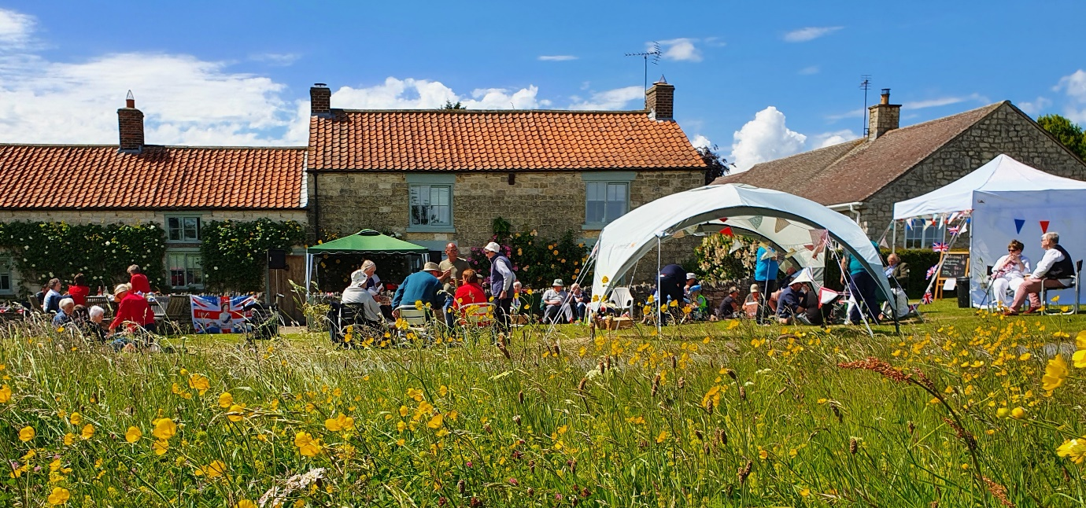

The meadow on the green has been stunning this year. At a brief count, we spotted 6 wild flower species among the grass and an Adonis Blue butterfly.

The Parish Council would like to thank Barugh Community Group for the loan of their gazebo; Mr Alan Lauren and his friend Mike Raynor, for the wonderful live music and everyone who came and contributed cakes, plants and their good company.

In the Autumn; the Parish Council would like to participate in the Queen’s Green Canopy project by planting a spinney of trees on the green at Little Barugh and some trees on the green verge at the top of Great Barugh. This will be on ongoing project to provide an amenity for all villagers to enjoy, with the ambition to plant additional wild flowers in the future.

We hope that the community will get involved in this project and we welcome your ideas and thoughts about it

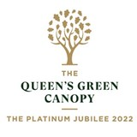

Please contact us to talk about this; if you would like to be added to our emailing list; would like to help with cake baking, volunteering for future events and anything else you wish to discuss.

Email: [greatandlittlebarughpc@gmail.com](mailto:greatandlittlebarughpc@gmail.com)

Or telephone either Sue Gough, Clerk at 01653 669513

Or Sarah Houlston, Chairman, at 01653 668274

**Other news;** the Vehicle Activated Sign in Great Barugh has been installed and is providing interesting data regarding traffic speeds that is currently being analysed.

**Gateway Signs for Little Barugh** are currently being investigated and will hopefully be installed in the Autumn.

**A Dog Waste bin** will be installed in each village in the near future.

**And finally:** a rather lovely blue willow pattern plate has been left behind and is at the Clock House, Little Barugh, telephone 01653 669513. Please call if it belongs to you and you would like to collect it!

**The Parish Council wishes you all a wonderful summer.**